**Python TRAINING**

**Task – 8(30th July)**

**SHAFALI GUPTA**

1. **Download PyCharm and make a project with any name.**

**Ans:-**

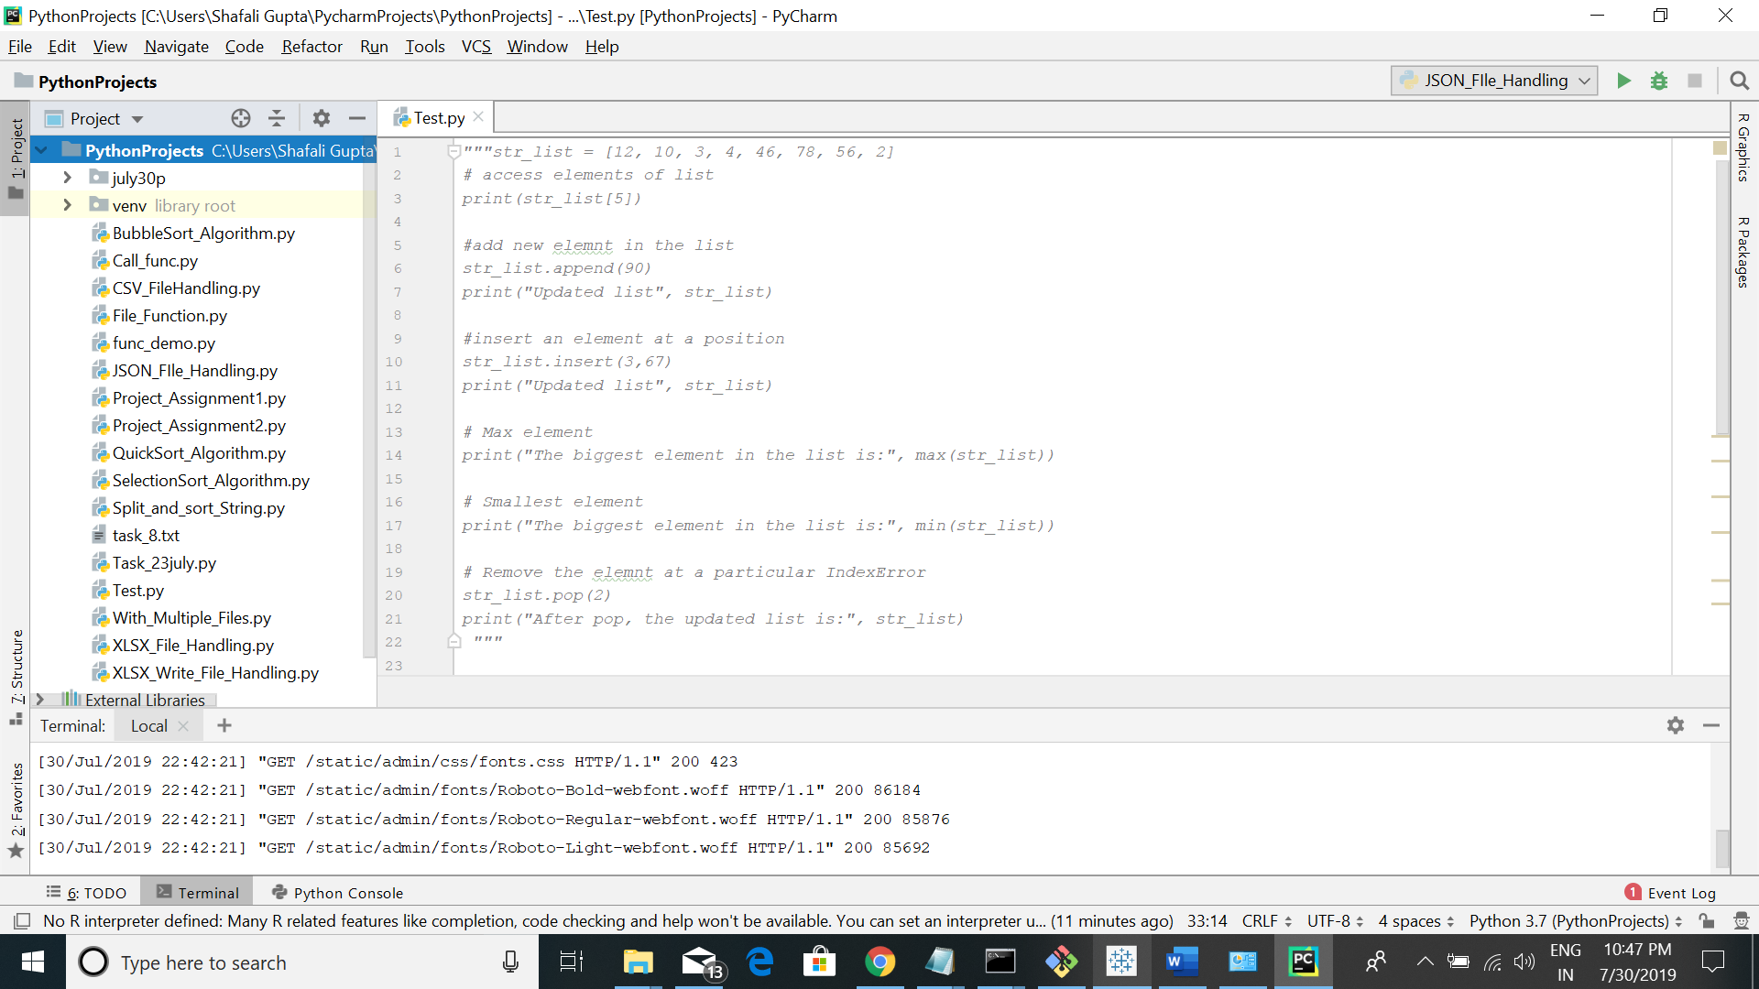

1. **Run the server using command python manage.py runserver.**

